[Swagger for Laravel – Tutorial – Raihan chowdhury](https://tuts.raihanchow.com/swagger-for-laravel/#:~:text=Integration%20of%20Swagger%20in%20Laravel%20Application%201%20Step,Swagger%20...%207%20Step%207%3A%20Open%20the%20Documentation)

**. if u you not install passport then firstly install password**

**And also install Auth like JWT or Sanctrum (use any one)**

**Teach_par Api Swagger**

**(Implemented in this project)**

## ****Integration of Swagger in Laravel Application****

Now here step by step to install and configure the swagger api for laravel documentations.

#### ****Step 1: Install Swagger open Api****

Now install the Swagger according to the Laravel version that you have installed. For more information visit [DarkaOnLine/L5-Swagger](https://github.com/DarkaOnLine/L5-Swagger/wiki/Installation-&-Configuration)

composer require "darkaonline/l5-swagger"

#### ****Step 2:**** ****Publish Swagger’s configuration****

You can publish Swagger’s configuration and view files into your project by running the following command.

php artisan vendor:publish --provider "L5Swagger\L5SwaggerServiceProvider"

#### ****Enable passport authentication****

Enable passport authentication we need to uncomment Open API 3.0 support in security array of config/l5-swagger.php file

'security' => [

// Open API 3.0 support

'passport' => [ // Unique name of security

'type' => 'oauth2', // The type of the security scheme. Valid values are "basic", "apiKey" or "oauth2".

'description' => 'Laravel passport oauth2 security.',

'in' => 'header',

'scheme' => 'https',

'flows' => [

"password" => [

"authorizationUrl" => config('app.url') . '/oauth/authorize',

"tokenUrl" => config('app.url') . '/oauth/token',

"refreshUrl" => config('app.url') . '/token/refresh',

"scopes" => []

],

],

],

],

#### ****Create Controller****

Now create a new controller AuthController using the following the command.

php artisan make:controller Api/AuthController

**USE THIS CODE IN CONTROLLER.PHP**

**MAIN THING IN APP/HTTP/CONTROLLERS/CONTROLLER.PHP**

<?php

namespace App\Http\Controllers;

use Illuminate\Foundation\Auth\Access\AuthorizesRequests;

use Illuminate\Foundation\Bus\DispatchesJobs;

use Illuminate\Foundation\Validation\ValidatesRequests;

use Illuminate\Routing\Controller as BaseController;

/**

 * @OA\Info(

 *    title="Your super  ApplicationAPI",

 *    version="1.0.0",

 * )

 * @OA\securitySchemes(

 *    @OA\bearerAuth(

 *      type="http",

 *      scheme="bearer",

 *      bearerFormat="JWT",

 *      security="bearerAuth: []",

 * )

 *

 */

class Controller extends BaseController

{

    use AuthorizesRequests, DispatchesJobs, ValidatesRequests;

}

Auth are two types santrum or JWT

Use any one , in this code JWT auth is used

***How to RUN***

1. **Generate Swagger**

To generate the swagger documentation file just run php artisan l5-swagger: generate command.

php artisan l5-swagger:generate

More then times when you generate the swagger It will return an error

Required @OA\Info() not found

1. Firstly run php artisan serve

Then open browser write *localhost:8000/api/documentation*

Swagger window will be open

For crud

[Laravel API documentation with Swagger - Kodementor](https://kodementor.com/laravel-api-documentation-with-swagger/)

-==

Swagger logout api how to run

1. Copy login token
2. Click on Authorize lock
3. 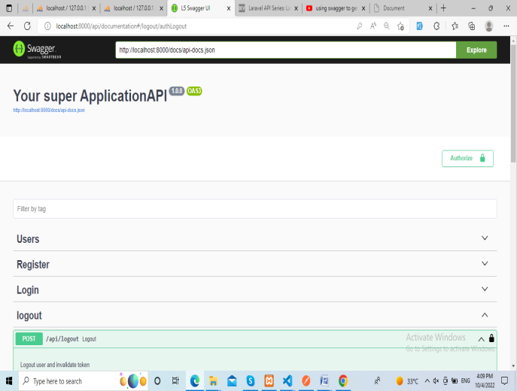

4. Past token and click on authorized , but don’t click on logout

1. Go in logout api 🡪 click on lock 🡪 past token then click on Authorized logout.
2. Then message show logout successfully.

**CRUD API IN SWAGGER**

1. **For store** data pass token 🡪 click on authorize (but don’t click on logout) when click on authorize lock looks locked.

Then pass title, desc and click on execute